实验6 使用ADO.NET访问数据库
实验类型：设计性实验 要求：必做 学时：4
实验时间及地点：

实验目的
1、掌握使用ADO.NET连接数据库的方法；
2、理解连接式与断开式两种访问模式的区别；
3、掌握使用ADO.NET技术操作数据的方法。
实验内容
1、使用ExecuteNonQuery方法更新数据。
2、使用DataAdapter对象添加数据。
3、更新指定的数据。
4、删除指定的数据。
5、上传图片存储到数据库。
实验步骤
1、使用ExecuteNonQuery方法更新数据。
根据输入的金额数，将test数据库中staff表中职称为“助教”的职工的工资增加。
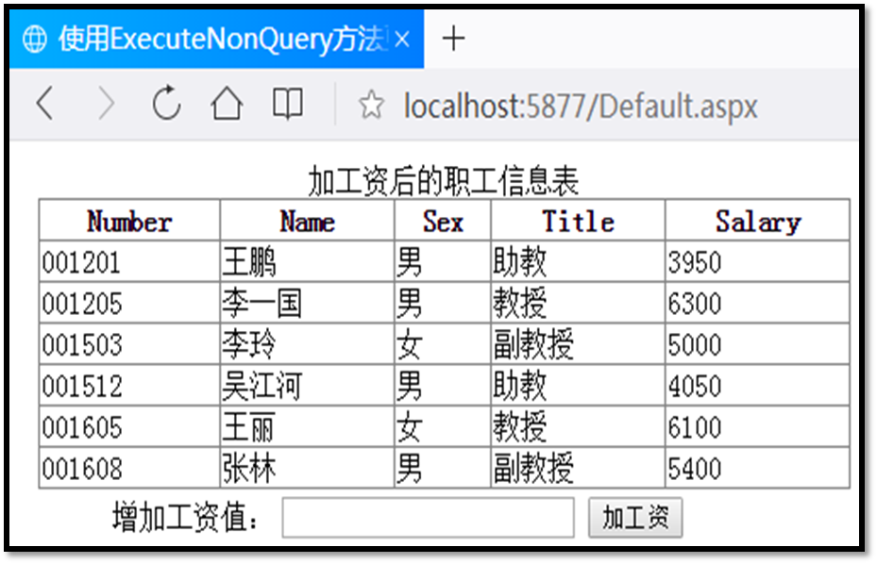
把关键代码填写到实验报告本上，并把运行结果截图贴到实验报告本上。
<%@ Page Language="C#" AutoEventWireup="true" CodeFile="sy6-1.aspx.cs" Inherits="sy6_1" %>

<!DOCTYPE html>

<html xmlns="http://www.w3.org/1999/xhtml">
<head runat="server">
<meta http-equiv="Content-Type" content="text/html; charset=utf-8"/>
<title></title>
</head>
<body>
<form id="form1" runat="server">
<div>
<asp:GridView ID="GridView1" runat="server" AllowPaging="True" AllowSorting="True" AutoGenerateColumns="False" DataKeyNames="Number" DataSourceID="SqlDataSource1">
<Columns>
<asp:BoundField DataField="Number" HeaderText="Number" ReadOnly="True" SortExpression="Number" />
<asp:BoundField DataField="Name" HeaderText="Name" SortExpression="Name" />
<asp:BoundField DataField="Sex" HeaderText="Sex" SortExpression="Sex" />
<asp:BoundField DataField="Title" HeaderText="Title" SortExpression="Title" />
<asp:BoundField DataField="Salary" HeaderText="Salary" SortExpression="Salary" />
</Columns>
</asp:GridView>
<asp:Label ID="Label1" runat="server" Text="增加工资值:"></asp:Label>
<asp:TextBox ID="TextBox1" runat="server"></asp:TextBox>
<asp:Button ID="Button1" runat="server" Text="增加工资" OnClick="Button1_Click" />

<asp:SqlDataSource ID="SqlDataSource1" runat="server" ConnectionString="<%$ ConnectionStrings:testConnectionString %>" SelectCommand="SELECT [Number], [Name], [Sex], [Title], [Salary] FROM [staff]" DeleteCommand="DELETE FROM [staff] WHERE [Number] = @Number" InsertCommand="INSERT INTO [staff] ([Number], [Name], [Sex], [Title], [Salary]) VALUES (@Number, @Name, @Sex, @Title, @Salary)" UpdateCommand="UPDATE [staff] SET [Name] = @Name, [Sex] = @Sex, [Title] = @Title, [Salary] = @Salary WHERE [Number] = @Number">
<DeleteParameters>
<asp:Parameter Name="Number" Type="String" />
</DeleteParameters>
<InsertParameters>
<asp:Parameter Name="Number" Type="String" />
<asp:Parameter Name="Name" Type="String" />
<asp:Parameter Name="Sex" Type="String" />
<asp:Parameter Name="Title" Type="String" />
<asp:Parameter Name="Salary" Type="Double" />
</InsertParameters>
<UpdateParameters>
<asp:Parameter Name="Name" Type="String" />
<asp:Parameter Name="Sex" Type="String" />
<asp:Parameter Name="Title" Type="String" />
<asp:Parameter Name="Salary" Type="Double" />
<asp:Parameter Name="Number" Type="String" />
</UpdateParameters>
</asp:SqlDataSource>
</div>
</form>
</body>
</html>

using System;
using System.Collections.Generic;
using System.Configuration;
using System.Data.SqlClient;
using System.Linq;
using System.Web;
using System.Web.UI;
using System.Web.UI.WebControls;

public partial class sy6_1 : System.Web.UI.Page
{
SqlConnection conn = new SqlConnection(ConfigurationManager.ConnectionStrings["testConnectionString"].ConnectionString);

protected void Page_Load(object sender, EventArgs e)
{
if (!this.IsPostBack)
{
GridView1.DataBind();
}
}

protected void Button1_Click(object sender, EventArgs e)
{
string value = TextBox1.Text;
string sqlStr = "update staff set salary=salary+" + value + " where title='助教'";
SqlCommand comm = new SqlCommand(sqlStr, conn);
conn.Open();
comm.ExecuteNonQuery();
conn.Close();
GridView1.DataBind();
}
}

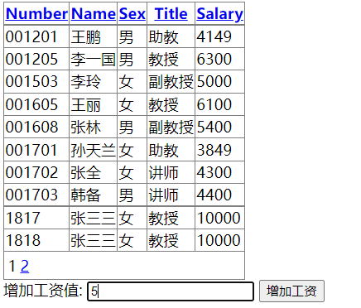
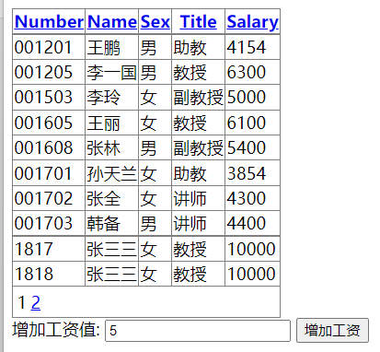
2、使用DataAdapter对象添加数据。
使用DataAdapter对象对test数据库中staff表进行操作，添加新记录。
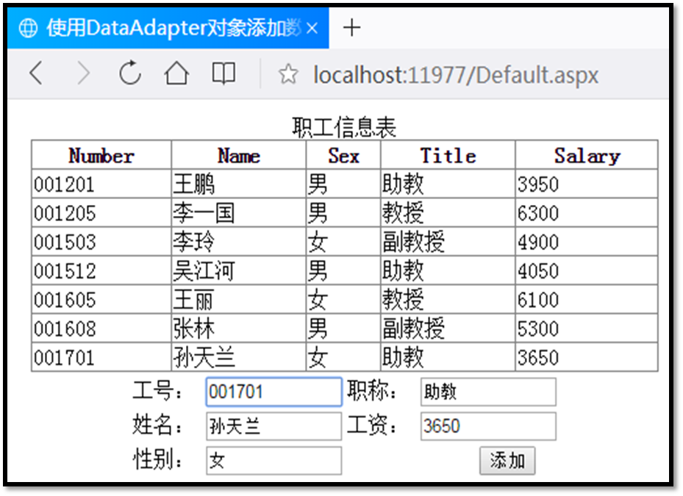
把关键代码填写到实验报告本上，并把运行结果截图贴到实验报告本上。
<%@ Page Language="C#" AutoEventWireup="true" CodeFile="sy6-2.aspx.cs" Inherits="sy6_2" %>

<!DOCTYPE html>

<html xmlns="http://www.w3.org/1999/xhtml">
<head runat="server">
<meta http-equiv="Content-Type" content="text/html; charset=utf-8"/>
<title></title>
</head>
<body>
<form id="form1" runat="server">
<div>
<asp:GridView ID="GridView1" runat="server" AllowPaging="True" AllowSorting="True" AutoGenerateColumns="False" DataKeyNames="Number" DataSourceID="SqlDataSource1">
<Columns>
<asp:BoundField DataField="Number" HeaderText="Number" ReadOnly="True" SortExpression="Number" />
<asp:BoundField DataField="Name" HeaderText="Name" SortExpression="Name" />
<asp:BoundField DataField="Sex" HeaderText="Sex" SortExpression="Sex" />
<asp:BoundField DataField="Title" HeaderText="Title" SortExpression="Title" />
<asp:BoundField DataField="Salary" HeaderText="Salary" SortExpression="Salary" />
</Columns>
</asp:GridView>
<asp:SqlDataSource ID="SqlDataSource1" runat="server" ConnectionString="<%$ ConnectionStrings:testConnectionString %>" SelectCommand="SELECT [Number], [Name], [Sex], [Title], [Salary] FROM [staff]"></asp:SqlDataSource>
工号：<asp:TextBox ID="wno" runat="server"></asp:TextBox> <br />
职称：<asp:TextBox ID="wname" runat="server"></asp:TextBox><br />
姓名：<asp:TextBox ID="name" runat="server"></asp:TextBox><br />
工资：<asp:TextBox ID="salary" runat="server"></asp:TextBox><br />
性别：<asp:TextBox ID="sex" runat="server"></asp:TextBox><br />
<asp:Button ID="Button1" runat="server" Text="添加" OnClick="Button1_Click" />
</div>
</form>
</body>
</html>

using System;
using System.Collections.Generic;
using System.Configuration;
using System.Data;
using System.Data.SqlClient;
using System.Linq;
using System.Web;
using System.Web.UI;
using System.Web.UI.WebControls;

public partial class sy6_2 : System.Web.UI.Page
{
SqlConnection conn = new SqlConnection(ConfigurationManager.ConnectionStrings["testConnectionString"].ConnectionString);

protected void Page_Load(object sender, EventArgs e)
{
GridView1.DataBind();
}

protected void Button1_Click(object sender, EventArgs e)
{
String wno = this.wno.Text;
String wname = this.wname.Text;
String name = this.name.Text;
String salary = this.salary.Text;
String sex = this.sex.Text;

string sqlStr = "insert into staff (Number,Title,Name,Salary,Sex) values (" + wno+",'"+wname+"','"+name+"',"+salary+",'"+sex+"')";
SqlCommand comm = new SqlCommand(sqlStr, conn);
conn.Open();
comm.ExecuteNonQuery();
conn.Close();
GridView1.DataBind();
}
}
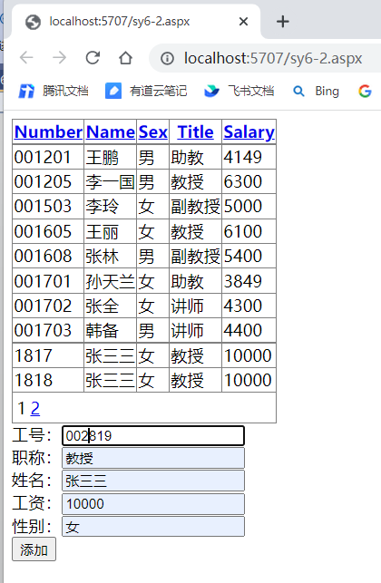
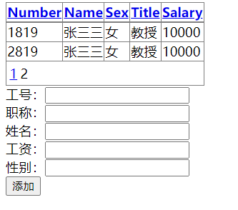
3、更新指定的数据。
在页面的表格中选定一行数据，更新其中的一列或多列的值。如下图所示，单击商品编号17003的一行中的“更新”超链接，在“商品数量”文本框中把牙刷的数量由50更新为80，单击“更新”按钮后，在GridView1控件中牙刷的数量将会由50更新为80。
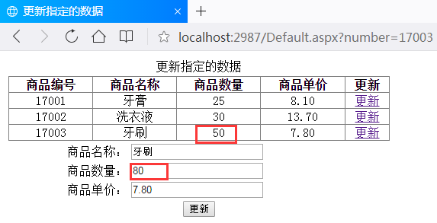
把关键代码填写到实验报告本上，并把运行结果截图贴到实验报告本上。
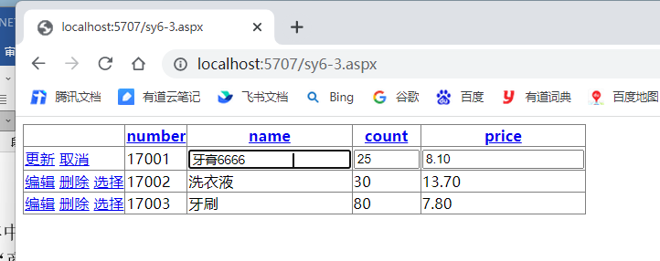
<%@ Page Language="C#" AutoEventWireup="true" CodeFile="sy6-3.aspx.cs" Inherits="sy6_3" %>

<!DOCTYPE html>

<html xmlns="http://www.w3.org/1999/xhtml">
<head runat="server">
<meta http-equiv="Content-Type" content="text/html; charset=utf-8"/>
<title></title>
</head>
<body>
<form id="form1" runat="server">
<div>
<asp:GridView ID="GridView1" runat="server" AllowPaging="True" AllowSorting="True" AutoGenerateColumns="False" DataKeyNames="number" DataSourceID="SqlDataSource1">
<Columns>
<asp:CommandField ShowDeleteButton="True" ShowEditButton="True" ShowSelectButton="True" />
<asp:BoundField DataField="number" HeaderText="number" ReadOnly="True" SortExpression="number" />
<asp:BoundField DataField="name" HeaderText="name" SortExpression="name" />
<asp:BoundField DataField="count" HeaderText="count" SortExpression="count" />
<asp:BoundField DataField="price" HeaderText="price" SortExpression="price" />
</Columns>
</asp:GridView>
<asp:SqlDataSource ID="SqlDataSource1" runat="server" ConflictDetection="CompareAllValues" ConnectionString="<%$ ConnectionStrings:testConnectionString %>" DeleteCommand="DELETE FROM [shopping] WHERE [number] = @original_number AND (([name] = @original_name) OR ([name] IS NULL AND @original_name IS NULL)) AND (([count] = @original_count) OR ([count] IS NULL AND @original_count IS NULL)) AND (([price] = @original_price) OR ([price] IS NULL AND @original_price IS NULL))" InsertCommand="INSERT INTO [shopping] ([number], [name], [count], [price]) VALUES (@number, @name, @count, @price)" OldValuesParameterFormatString="original_{0}" SelectCommand="SELECT [number], [name], [count], [price] FROM [shopping]" UpdateCommand="UPDATE [shopping] SET [name] = @name, [count] = @count, [price] = @price WHERE [number] = @original_number AND (([name] = @original_name) OR ([name] IS NULL AND @original_name IS NULL)) AND (([count] = @original_count) OR ([count] IS NULL AND @original_count IS NULL)) AND (([price] = @original_price) OR ([price] IS NULL AND @original_price IS NULL))">
<DeleteParameters>
<asp:Parameter Name="original_number" Type="String" />
<asp:Parameter Name="original_name" Type="String" />
<asp:Parameter Name="original_count" Type="Int32" />
<asp:Parameter Name="original_price" Type="Decimal" />
</DeleteParameters>
<InsertParameters>
<asp:Parameter Name="number" Type="String" />
<asp:Parameter Name="name" Type="String" />
<asp:Parameter Name="count" Type="Int32" />
<asp:Parameter Name="price" Type="Decimal" />
</InsertParameters>
<UpdateParameters>
<asp:Parameter Name="name" Type="String" />
<asp:Parameter Name="count" Type="Int32" />
<asp:Parameter Name="price" Type="Decimal" />
<asp:Parameter Name="original_number" Type="String" />
<asp:Parameter Name="original_name" Type="String" />
<asp:Parameter Name="original_count" Type="Int32" />
<asp:Parameter Name="original_price" Type="Decimal" />
</UpdateParameters>
</asp:SqlDataSource>
</div>
</form>
</body>
</html>

4、删除指定的数据。
在页面中选定test数据库中staff表中的一行数据删除。如图所示，在表中单击最后一行数据所在行的“删除”按钮后实现这行数据的删除。
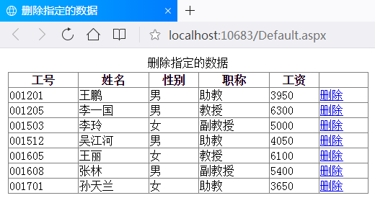
把关键代码填写到实验报告本上，并把运行结果截图贴到实验报告本上。
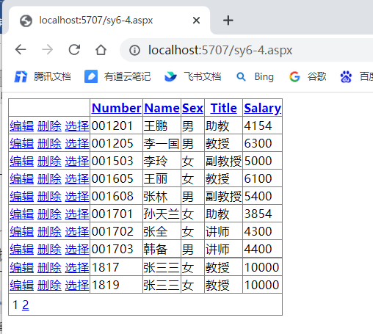
<%@ Page Language="C#" AutoEventWireup="true" CodeFile="sy6-4.aspx.cs" Inherits="sy6_4" %>

<!DOCTYPE html>

<html xmlns="http://www.w3.org/1999/xhtml">
<head runat="server">
<meta http-equiv="Content-Type" content="text/html; charset=utf-8"/>
<title></title>
</head>
<body>
<form id="form1" runat="server">
<div>
<asp:GridView ID="GridView1" runat="server" AllowPaging="True" AllowSorting="True" AutoGenerateColumns="False" DataKeyNames="Number" DataSourceID="SqlDataSource1">
<Columns>
<asp:CommandField ShowDeleteButton="True" ShowEditButton="True" ShowSelectButton="True" />
<asp:BoundField DataField="Number" HeaderText="Number" ReadOnly="True" SortExpression="Number" />
<asp:BoundField DataField="Name" HeaderText="Name" SortExpression="Name" />
<asp:BoundField DataField="Sex" HeaderText="Sex" SortExpression="Sex" />
<asp:BoundField DataField="Title" HeaderText="Title" SortExpression="Title" />
<asp:BoundField DataField="Salary" HeaderText="Salary" SortExpression="Salary" />
</Columns>
</asp:GridView>
<asp:SqlDataSource ID="SqlDataSource1" runat="server" ConflictDetection="CompareAllValues" ConnectionString="<%$ ConnectionStrings:testConnectionString %>" DeleteCommand="DELETE FROM [staff] WHERE [Number] = @original_Number AND (([Name] = @original_Name) OR ([Name] IS NULL AND @original_Name IS NULL)) AND (([Sex] = @original_Sex) OR ([Sex] IS NULL AND @original_Sex IS NULL)) AND (([Title] = @original_Title) OR ([Title] IS NULL AND @original_Title IS NULL)) AND (([Salary] = @original_Salary) OR ([Salary] IS NULL AND @original_Salary IS NULL))" InsertCommand="INSERT INTO [staff] ([Number], [Name], [Sex], [Title], [Salary]) VALUES (@Number, @Name, @Sex, @Title, @Salary)" OldValuesParameterFormatString="original_{0}" SelectCommand="SELECT [Number], [Name], [Sex], [Title], [Salary] FROM [staff]" UpdateCommand="UPDATE [staff] SET [Name] = @Name, [Sex] = @Sex, [Title] = @Title, [Salary] = @Salary WHERE [Number] = @original_Number AND (([Name] = @original_Name) OR ([Name] IS NULL AND @original_Name IS NULL)) AND (([Sex] = @original_Sex) OR ([Sex] IS NULL AND @original_Sex IS NULL)) AND (([Title] = @original_Title) OR ([Title] IS NULL AND @original_Title IS NULL)) AND (([Salary] = @original_Salary) OR ([Salary] IS NULL AND @original_Salary IS NULL))">
<DeleteParameters>
<asp:Parameter Name="original_Number" Type="String" />
<asp:Parameter Name="original_Name" Type="String" />
<asp:Parameter Name="original_Sex" Type="String" />
<asp:Parameter Name="original_Title" Type="String" />
<asp:Parameter Name="original_Salary" Type="Double" />
</DeleteParameters>
<InsertParameters>
<asp:Parameter Name="Number" Type="String" />
<asp:Parameter Name="Name" Type="String" />
<asp:Parameter Name="Sex" Type="String" />
<asp:Parameter Name="Title" Type="String" />
<asp:Parameter Name="Salary" Type="Double" />
</InsertParameters>
<UpdateParameters>
<asp:Parameter Name="Name" Type="String" />
<asp:Parameter Name="Sex" Type="String" />
<asp:Parameter Name="Title" Type="String" />
<asp:Parameter Name="Salary" Type="Double" />
<asp:Parameter Name="original_Number" Type="String" />
<asp:Parameter Name="original_Name" Type="String" />
<asp:Parameter Name="original_Sex" Type="String" />
<asp:Parameter Name="original_Title" Type="String" />
<asp:Parameter Name="original_Salary" Type="Double" />
</UpdateParameters>
</asp:SqlDataSource>
</div>
</form>
</body>
</html>

5、上传图片存储到数据库
将上传图片存储到到数据库test的表picSend中，并把图片保存到指定文件夹下。
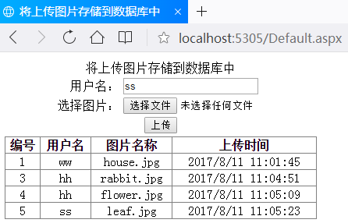
把关键代码填写到实验报告本上，并把运行结果截图贴到实验报告本上。
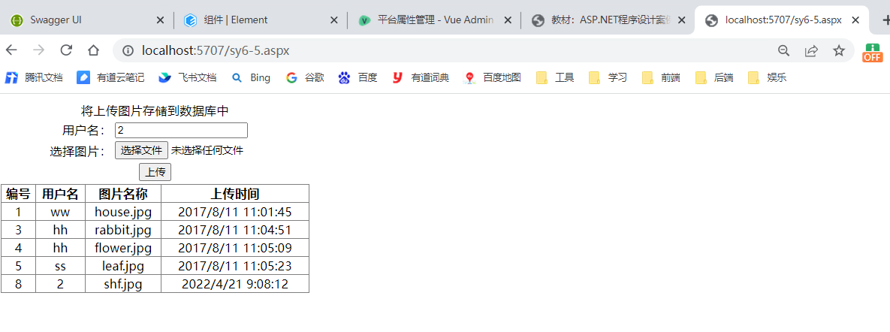

<%@ Page Language="C#" AutoEventWireup="true" CodeFile="sy6-5.aspx.cs" Inherits="sy6_5" %>

<!DOCTYPE html>

<html xmlns="http://www.w3.org/1999/xhtml">
<head runat="server">
<meta http-equiv="Content-Type" content="text/html; charset=utf-8"/>
<title></title>
</head>
<body>
<form id="form1" runat="server">
<table style="width: 400px;">
<tr>
<td colspan="2" style="text-align: center">将上传图片存储到数据库中</td>
</tr>
<tr>
<td style="width: 150px; text-align: right;">用户名：</td>
<td style="text-align: left; width: 250px;">
<asp:TextBox ID="TextBox1" runat="server"></asp:TextBox>
</td>
</tr>
<tr>
<td style="width: 150px; text-align: right;">选择图片：</td>
<td style="text-align: left; width: 250px;">
<asp:FileUpload ID="FileUpload1" runat="server" />
</td>
</tr>
<tr>
<td colspan="2" style="text-align: center">
<asp:Button ID="Button1" runat="server" OnClick="Button1_Click" Text="上传" />
</td>
</tr>
<tr>
<td colspan="2" style="text-align: center">
<asp:GridView ID="GridView1" runat="server" AutoGenerateColumns="False" HorizontalAlign="Center" Width="400px">
<Columns>
<asp:BoundField DataField="id" HeaderText="编号" />
<asp:BoundField DataField="name" HeaderText="用户名" />
<asp:BoundField DataField="picname" HeaderText="图片名称" />
<asp:BoundField DataField="sendtime" HeaderText="上传时间" />
</Columns>
</asp:GridView>
</td>
</tr>
</table>
</form>
</body>
</html>

using System;
using System.Collections.Generic;
using System.Configuration;
using System.Data;
using System.Data.SqlClient;
using System.Linq;
using System.Web;
using System.Web.UI;
using System.Web.UI.WebControls;

public partial class sy6_5 : System.Web.UI.Page
{
SqlConnection conn = new SqlConnection(ConfigurationManager.ConnectionStrings["testConnectionString"].ConnectionString);

protected void Page_Load(object sender, EventArgs e)
{

}
//绑定GridView控件显示上传图片表中的内容
protected void gvBind()
{
conn.Open();
string sqltext = "select * from picSend";
SqlDataAdapter sda = new SqlDataAdapter(sqltext, conn);
DataSet ds = new DataSet();
sda.Fill(ds);
conn.Close();
GridView1.DataSource = ds.Tables[0].DefaultView;
GridView1.DataBind();
}
protected void Button1_Click(object sender, EventArgs e)
{
string Name = TextBox1.Text;
string pictureName = FileUpload1.FileName; //获取文件名称
string sendTime = DateTime.Now.ToString(); //获取当前时间
//获取上传文件的后缀名
string lastName = pictureName.Substring(pictureName.LastIndexOf(".") + 1);
if (lastName.ToLower() == "jpg" || lastName.ToLower() == "bmp" || lastName.ToLower() == "gif")
{
string SavePath = Server.MapPath("images/") + pictureName; //设置保存路径
FileUpload1.PostedFile.SaveAs(SavePath); //保存上传的图片
string sql = "insert into picSend(name,picname,sendtime) values('"
+ Name + "','" + pictureName + "','" + sendTime + "')";
conn.Open();
SqlCommand com = new SqlCommand(sql, conn);
com.ExecuteNonQuery();
conn.Close();
gvBind();
}
else
Response.Write("<script language=javascript>alert('图片格式不正确！')</script>");
}
}
实验小结
通过本次实验我学会使用ADO.NET技术，其中的Command对象、DataReader对象、DataAdapter对象、DataSet对象

